Laboratory Program 1

Topology

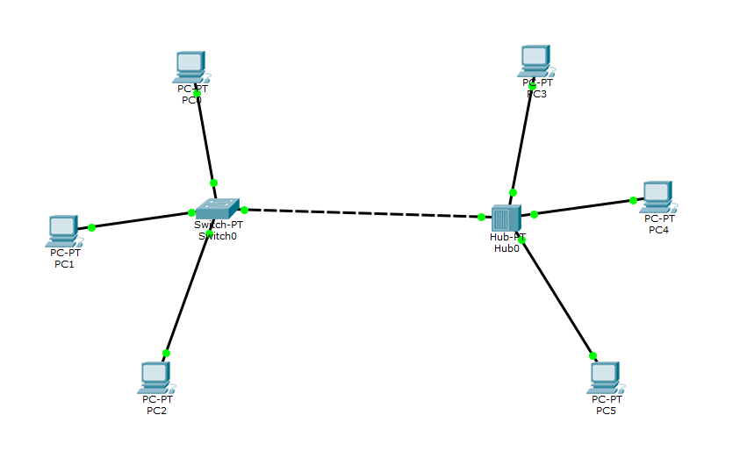

Output

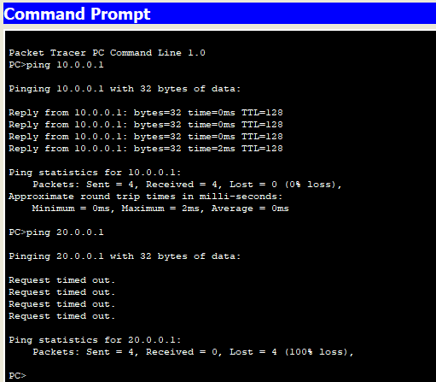

Laboratory Program 2

Part 1

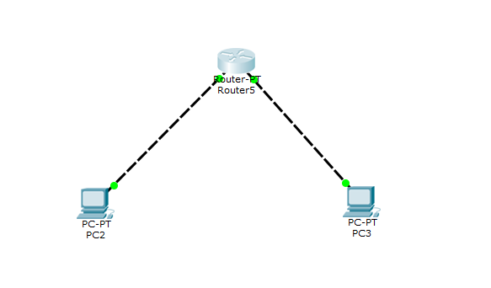

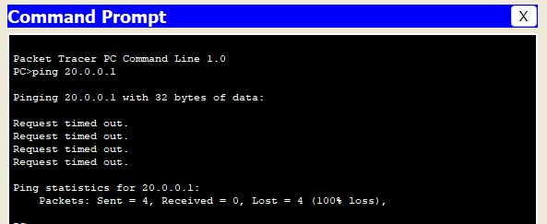

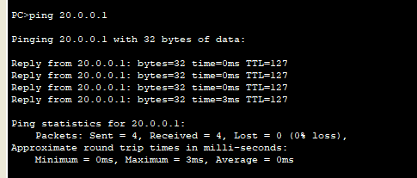

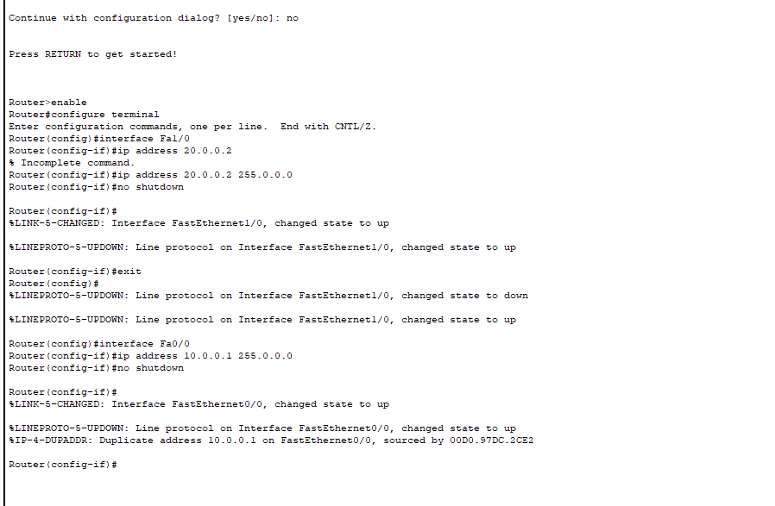

Part 2

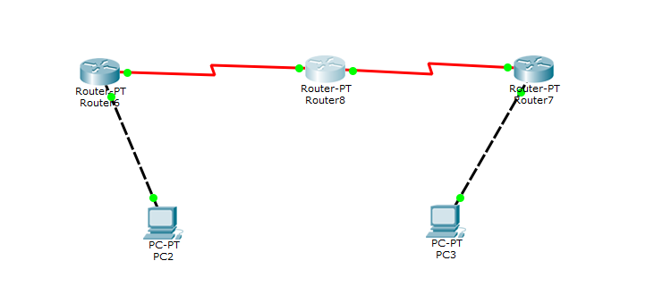

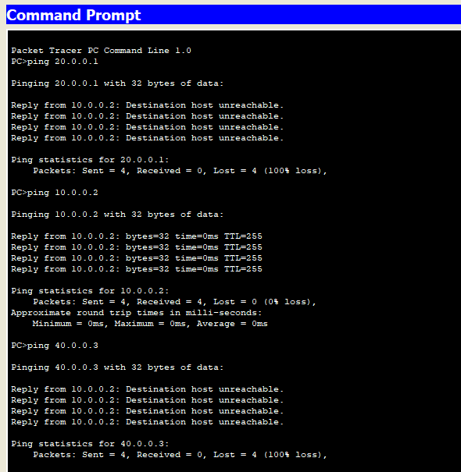

Laboratory Program 3

Part 1

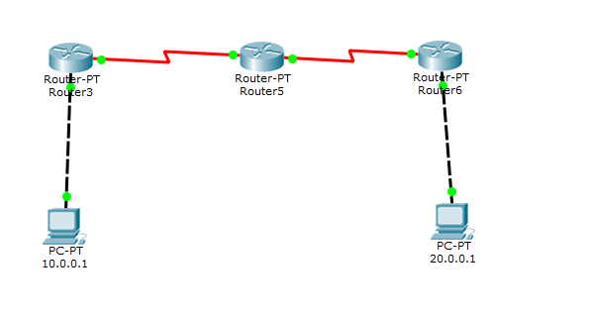

Router Configuration

/*Router3*/

Router>enable

Router#configure terminal

Enter configuration commands, one per line. End with CNTL/Z.

Router(config)#ip route 20.0.0.0 255.0.0.0 30.0.0.1

Router(config)#ip route 40.0.0.0 255.0.0.0 30.0.0.1

Router(config)#exit

Router#

%SYS-5-CONFIG_I: Configured from console by console

Router#show ip route

Codes: C - connected, S - static, I - IGRP, R - RIP, M - mobile, B - BGP

D - EIGRP, EX - EIGRP external, O - OSPF, IA - OSPF inter area

N1 - OSPF NSSA external type 1, N2 - OSPF NSSA external type 2

E1 - OSPF external type 1, E2 - OSPF external type 2, E - EGP

i - IS-IS, L1 - IS-IS level-1, L2 - IS-IS level-2, ia - IS-IS inter area

* - candidate default, U - per-user static route, o - ODR

P - periodic downloaded static route

Gateway of last resort is not set

C 10.0.0.0/8 is directly connected, FastEthernet0/0

S 20.0.0.0/8 [1/0] via 40.0.0.4

[1/0] via 30.0.0.1

C 30.0.0.0/8 is directly connected, Serial2/0

S 40.0.0.0/8 [1/0] via 30.0.0.1

/*Router5*/

Router>enable

Router#configure terminal

Enter configuration commands, one per line. End with CNTL/Z.

Router(config)#ip route 20.0.0.0 255.0.0.0 40.0.0.4

Router(config)#ip route 10.0.0.0 255.0.0.0 30.0.0.2

Router(config)#exit

Router#

%SYS-5-CONFIG_I: Configured from console by console

Router#show ip route

Codes: C - connected, S - static, I - IGRP, R - RIP, M - mobile, B - BGP

D - EIGRP, EX - EIGRP external, O - OSPF, IA - OSPF inter area

N1 - OSPF NSSA external type 1, N2 - OSPF NSSA external type 2

E1 - OSPF external type 1, E2 - OSPF external type 2, E - EGP

i - IS-IS, L1 - IS-IS level-1, L2 - IS-IS level-2, ia - IS-IS inter area

* - candidate default, U - per-user static route, o - ODR

P - periodic downloaded static route

Gateway of last resort is not set

S 10.0.0.0/8 [1/0] via 30.0.0.2

S 20.0.0.0/8 [1/0] via 40.0.0.4

C 30.0.0.0/8 is directly connected, Serial2/0

C 40.0.0.0/8 is directly connected, Serial3/0

/*Router6*/

S 10.0.0.0/8 [1/0] via 40.0.0.3

C 20.0.0.0/8 is directly connected, FastEthernet0/0

C 40.0.0.0/8 is directly connected, Serial3/0

Router#configure terminal

Enter configuration commands, one per line. End with CNTL/Z.

Router(config)#ip route 30.0.0.0 255.0.0.0 40.0.0.3

Router(config)#ip route 10.0.0.0 255.0.0.0 40.0.0.3

Router(config)#exit

Router#

%SYS-5-CONFIG_I: Configured from console by console

Router#show ip route

Codes: C - connected, S - static, I - IGRP, R - RIP, M - mobile, B - BGP

D - EIGRP, EX - EIGRP external, O - OSPF, IA - OSPF inter area

N1 - OSPF NSSA external type 1, N2 - OSPF NSSA external type 2

E1 - OSPF external type 1, E2 - OSPF external type 2, E - EGP

i - IS-IS, L1 - IS-IS level-1, L2 - IS-IS level-2, ia - IS-IS inter area

* - candidate default, U - per-user static route, o - ODR

P - periodic downloaded static route

Gateway of last resort is not set

S 10.0.0.0/8 [1/0] via 40.0.0.3

[1/0] via 30.0.0.1

C 20.0.0.0/8 is directly connected, FastEthernet0/0

S 30.0.0.0/8 [1/0] via 40.0.0.3

C 40.0.0.0/8 is directly connected, Serial3/0

Output

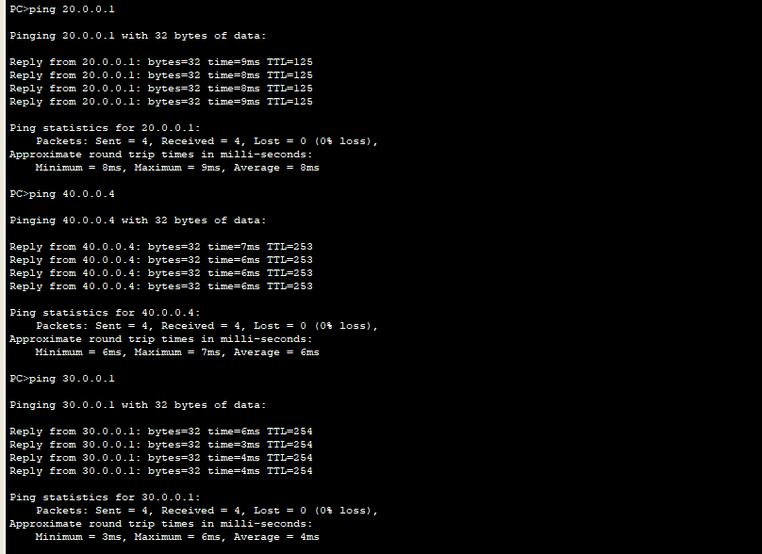

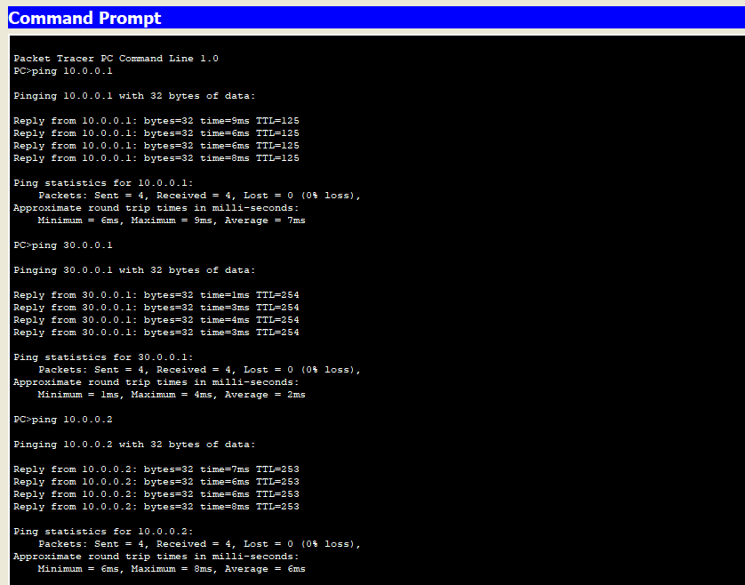

Part 2

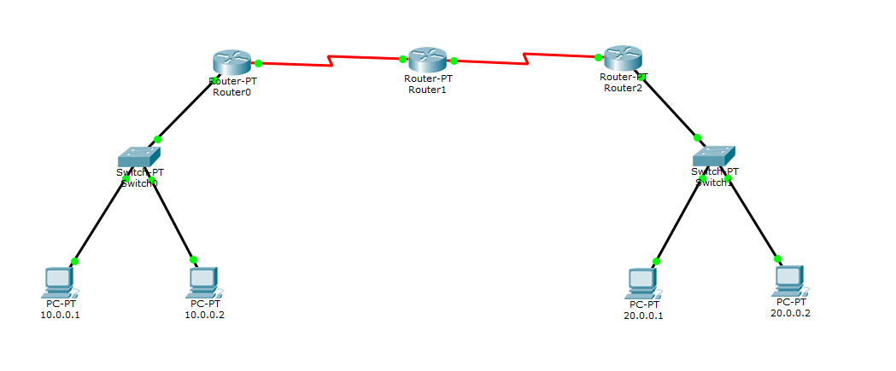

Router Configuration

/*Router 1*/

Router(config-if)#exit

Router(config)#ip route 0.0.0.0 0.0.0.0 30.0.0.2

Router(config)#exit

Router#

%SYS-5-CONFIG_I: Configured from console by console

Router#show ip route

Codes: C - connected, S - static, I - IGRP, R - RIP, M - mobile, B - BGP

D - EIGRP, EX - EIGRP external, O - OSPF, IA - OSPF inter area

N1 - OSPF NSSA external type 1, N2 - OSPF NSSA external type 2

E1 - OSPF external type 1, E2 - OSPF external type 2, E - EGP

i - IS-IS, L1 - IS-IS level-1, L2 - IS-IS level-2, ia - IS-IS inter area

* - candidate default, U - per-user static route, o - ODR

P - periodic downloaded static route

Gateway of last resort is 30.0.0.1 to network 0.0.0.0

C 10.0.0.0/8 is directly connected, FastEthernet0/0

C 30.0.0.0/8 is directly connected, Serial2/0

S* 0.0.0.0/0 [1/0] via 30.0.0.1

[1/0] via 30.0.0.2

/*Router 2*/

Router(config)#ip route 10.0.0.0 255.0.0.0 30.0.0.1

Router(config)#ip route 20.0.0.0 255.0.0.0 40.0.0.2

Router(config)#exit

Router#

%SYS-5-CONFIG_I: Configured from console by console

Router#show ip route

Codes: C - connected, S - static, I - IGRP, R - RIP, M - mobile, B - BGP

D - EIGRP, EX - EIGRP external, O - OSPF, IA - OSPF inter area

N1 - OSPF NSSA external type 1, N2 - OSPF NSSA external type 2

E1 - OSPF external type 1, E2 - OSPF external type 2, E - EGP

i - IS-IS, L1 - IS-IS level-1, L2 - IS-IS level-2, ia - IS-IS inter area

* - candidate default, U - per-user static route, o - ODR

P - periodic downloaded static route

Gateway of last resort is not set

S 10.0.0.0/8 [1/0] via 30.0.0.1

S 20.0.0.0/8 [1/0] via 40.0.0.2

C 30.0.0.0/8 is directly connected, Serial2/0

C 40.0.0.0/8 is directly connected, Serial3/0

/*Router 3*/

Router(config-if)#exit

Router(config)#ip route 0.0.0.0 0.0.0.0 40.0.0.1

Router(config)#exit

Router#

%SYS-5-CONFIG_I: Configured from console by console

Router#show ip

% Incomplete command.

Router#show ip route

Codes: C - connected, S - static, I - IGRP, R - RIP, M - mobile, B - BGP

D - EIGRP, EX - EIGRP external, O - OSPF, IA - OSPF inter area

N1 - OSPF NSSA external type 1, N2 - OSPF NSSA external type 2

E1 - OSPF external type 1, E2 - OSPF external type 2, E - EGP

i - IS-IS, L1 - IS-IS level-1, L2 - IS-IS level-2, ia - IS-IS inter area

* - candidate default, U - per-user static route, o - ODR

P - periodic downloaded static route

Gateway of last resort is 40.0.0.1 to network 0.0.0.0

C 20.0.0.0/8 is directly connected, FastEthernet0/0

C 40.0.0.0/8 is directly connected, Serial3/0

S* 0.0.0.0/0 [1/0] via 40.0.0.1

Output

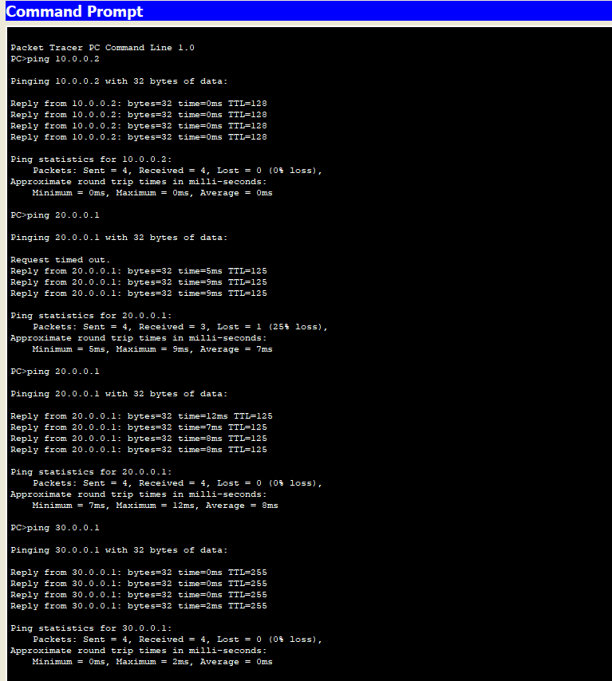

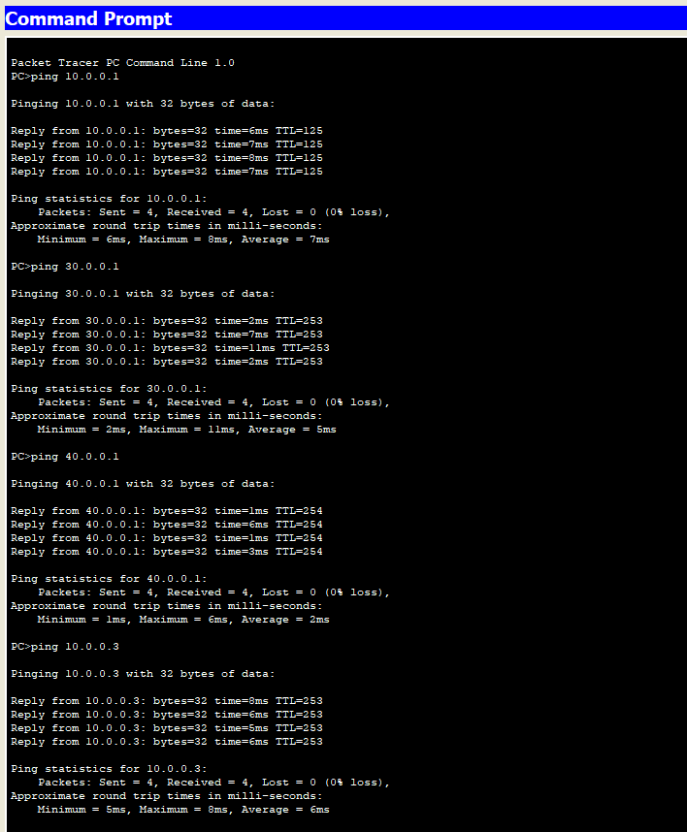

Laboratory Program 4

Part 1 – Internal LAN

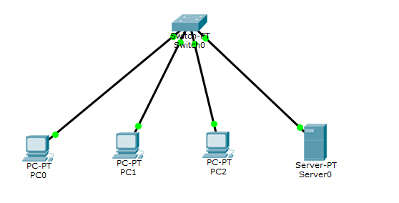

Server Configuration

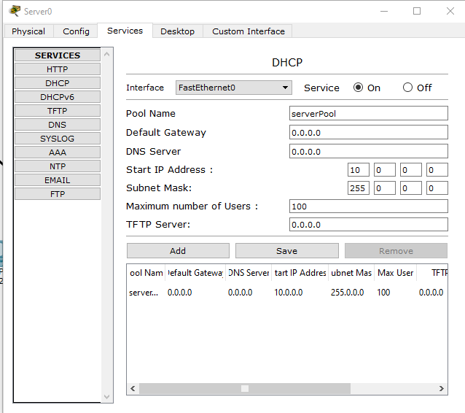

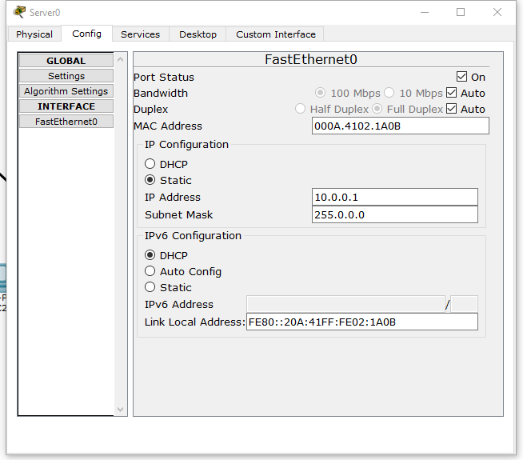

Output

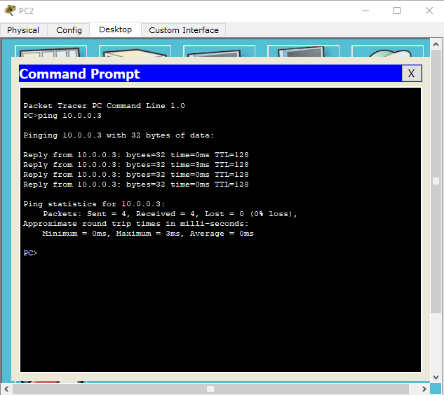

PC Configuration

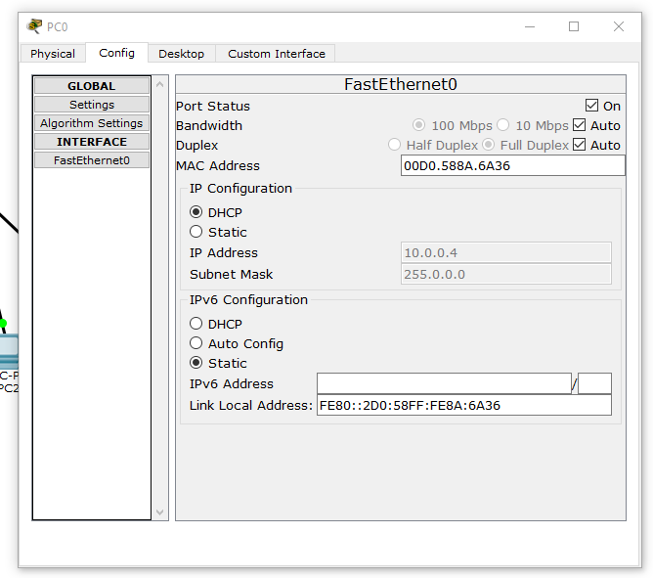

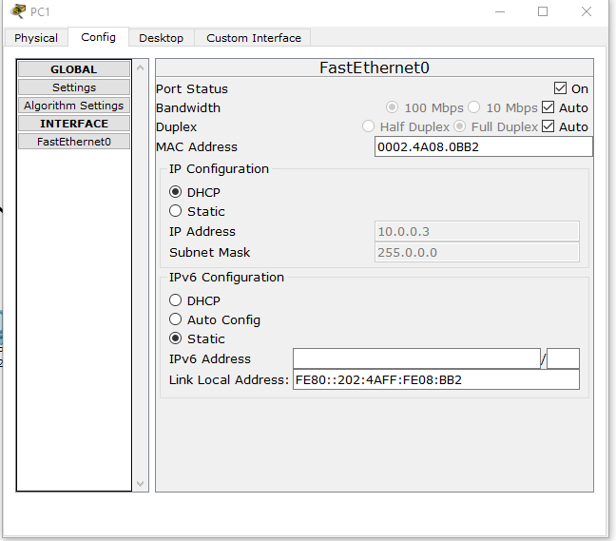

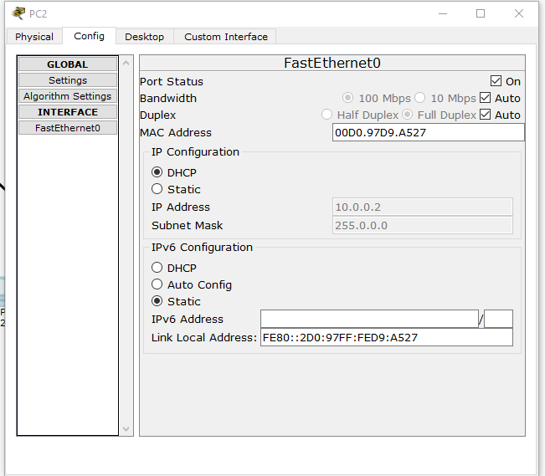

Part 2 – Outer LAN

Topology

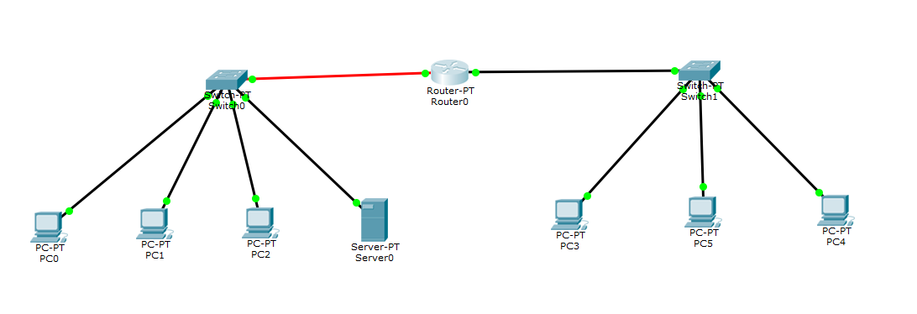

Server Configuration

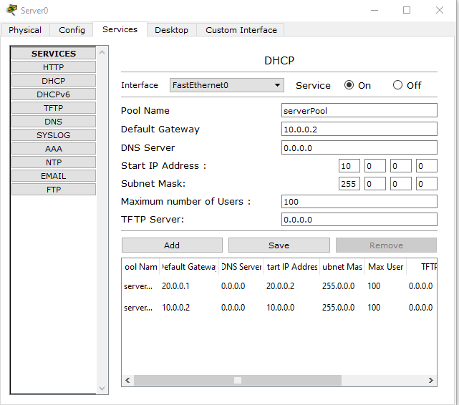

Laboratory Program 5

Part 1

Topology

Output

Part 2